A - Requirements Review
Highlight nouns, verbs and business rules in SmartCare v0.2.

Nouns
Patient
Practitioner
Receptionist
Clinic management
Appointment
Appointment history
Patient record
Practitioner record
Schedule
Time slot
Availability
Duplicate booking
Status
Search
Reporting
Performance reports
Financial reports
Authentication
User roles
Audit logs
Privacy laws
Name
DOB
Gender
Appointment details

Verbs
Book appointments
Update patient records
Search for patients
Create patient records
Prevent duplicate bookings
Update appointment details
Cancel appointments
Show appointment details
Patients book appointments
Practitioners view appointment history
Receptionists search, update, and manage bookings
Management reviews reports

Create practitioner records
Display appointment history
Update practitioner records
Show schedules
Load records
Display records
Authenticate users

Business rules
Each appointment must link to exactly one patient.
Each appointment must link to exactly one practitioner.
Duplicate bookings must be prevented.
Appointment status must be tracked example confirmed
Staff must be able to update patient and practitioner records.
Practitioners must be able to view patient history before appointments.
Receptionists manage all appointment creation, updates, and cancellations.
Appointment details must be complete before saving.
The system must load records within 3 seconds.
The system must support at least 12 concurrent users.
The system must enforce user roles and authentication.
The system must follow strict privacy laws.
The system must produce audit logs.

B - Candidate Classes
Record candidate concepts, supporting requirements, state and behaviour.

Candidate | Class? | Reason
Patient | Is a class | Patient as multiple attributes being name,age,gender ect
Practitioner | Is a class | Same as the patient with them having name,gender,
Appointment | Is a class | Will have attributes like time,type,room,
Name | Not a class | Is an attribute for a patient or practitioner
Clinic | A class | Clinic is a physical location which will have attributes like location and opening hours
Database | Not a class | A database is something that holds all the information is just a implantation
Cancellation | Not a class | Is just a check for if the appointment is available is just a state to see if the appointment is happening
Status | Not a class | Status is an attribute for appointment as it i checks an appointment status

Requirement | Concept | State/behaviour | Decision
Staff create patient records | Patient | State using the patient’s id, name, dob, gender.  Behaviour: making the record and updating the details | Accepted
Staff create patient records | Practitioner | Same as the patient, their id, name, age ect.  Behaviour.would be finding out about the practitioners | Accepted
System shows all appointment details | Appointment | The state would be the appointments attributes the date,time,room etc and behaviour would be viewing details and updating appointments | Accepted
Prevent duplicate bookings | Appointment | Behaviour is checking for if there is any duplicate bookings | Behaviour only

C - CRC Cards
Create CRC cards for Patient, Practitioner and Appointment.

Patient

Responsibilities | Collaborators
Allow Staff to change and update patient information when need | Practitioner- checks on the patient and views everything to prepare to meet with the patient
Provide staff searchable patient information when finding patient in database | Appointment - links to to patients appointment history
Give patient details to staff to store(name,DOb,etc) | Receptionist-Search, updates and creates patient records

Practitioner

Responsibilities | Collaborators
Store practitioner details(name,age,DOB,etc) | Appointment - practitioners are assigned to an appointment
Allowed to look at patient records when preparing for an appointment | Patient- practitioners search and look though patient information to prepare for the appointment
Provide practitioners availability for scheduling | Receptionist-can update practitioner’s appointments to another time and update their record

Appointment

Responsibilities | Collaborators
Prevent duplicate bookings | Patients -links to to patients appointment history
Store appointment details(date,time,etc) | Appointment - practitioners are assigned to an appointment
Allow Receptionist to update appointment details | Receptionist-can create,update,cancel and manage booked and upcoming appointments
Allow Receptionist to cancel appointment

D - UML Model
Draw classes, attributes, operations, associations and multiplicities.

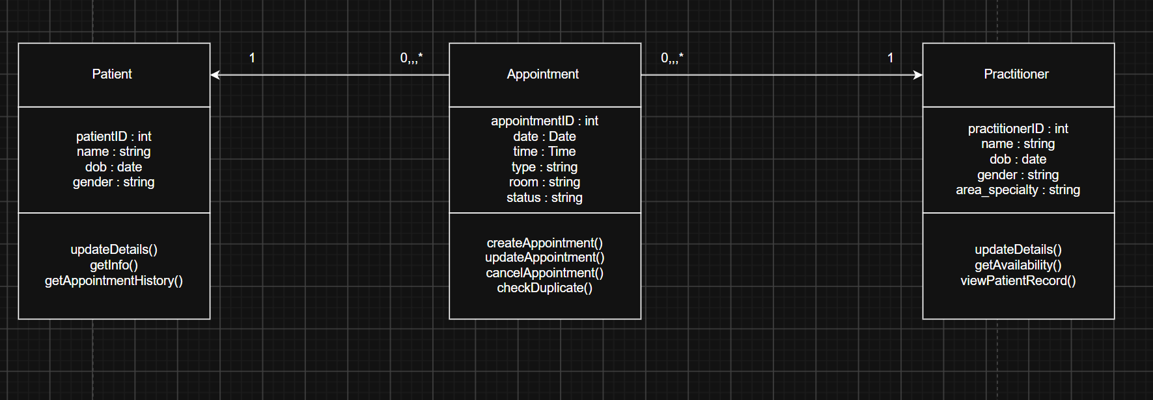

Design Rationale
Explain class selection, responsibility allocation and key relationships.

The class selection
.Patient stores personal details and links to appointment history.

.Practitioner stores professional details, availability, and links to appointments.

.Appointment represents the scheduled interaction between a patient and a practitioner

Focuses on keeping the model simple to avoid unnecessary complexity

responsibility allocation

Patient is responsible for giving and advertising new patient information and providing access to appointment history

Practitioner is responsible for maintaining practitioner details, availability, and viewing patient history

Appointment handles scheduling, updating, cancellation, and duplicate‑booking checks

This ensures that all classes have clear responsibilities and avoids overdesign from ai

Key relationships
Patient to appointment one to many

Practitioner to appointment one to many

Each appointment have exactly one practitioner and one patient while there have many

Compare and Decide
Record at least one accepted, modified and rejected AI suggestion.

Accepted
AI Suggestion: Receptionists can add and create appointments.
And practitioners can view past patient appointments

Modified
Duplicate booking rules missing
Modified
FR‑04(the system will block and prevent duplicate bookings) exists but doesn’t explain the duplicate bookings

Rejected
AI Suggestion: Wi‑Fi reliability assumed.
Reason: There is no requirement mentioning internet reliability.
Model:not changed

Python Skeletons

Create simple Patient, Practitioner and Appointment class skeletons.
Patient
class Patient:
def __init__(self, patient_id, name, dob, gender):
self.patient_id = patient_id
self.name = name
self.dob = dob
self.gender = gender

Practitioner
class Practitioner:
def __init__(self, practitioner_id, name, dob, gender, area_specialty):
self.practitioner_id = practitioner_id
self.name = name
self.dob = dob
self.gender = gender
self.area_specialty = area_specialty

Appointment
class Appointment:
def __init__(self, appointment_id, date, time, type, room, status):
self.appointment_id = appointment_id
self.date = date
self.time = time
self.type = type
self.room = room
self.status = status

H - Consistency Check
Check model-code consistency; do not implement full behaviour yet.

Patient
Has patient attributes like name,DOB,gender
Patient is responsible for giving and advertising new patient information and providing access to appointment history
The python skeleton has these attributes
And the uml has these attributes and simple operations

Practitioner
Has attributes that are in the uml and python skelton
Has a clear responsibility of maintaining practitioner details, availability, and viewing patient history
And operations are shown in the uml
appointment
Has attributes that are in the uml and python skeleton like example time
Has a clear responsibility of handling scheduling, updating, cancellation, and duplicate‑booking checks
And operations are shown in the uml

Reflection
The hardest modeling decision was making sure that there was minimal classes and to just stick with the core classes patient,practitioner,appointment,Receptionist and clinic is also a class but Wanted to see first use the 3 core classes first.Where I think ai overdesigned was with using every noun and turning them into a class as a class kept suggesting new classes like a manger for patient or a cancellation or schedule class which are better represented as attributes.Evidence is the requirements as patient,practitioner and appointments have a lot of requirements backing them up as classes None of the AI‑suggested classes had any requirement support. To make them be classes.

